Progress Report of the Development of the Japanese Virtual Observatory
January 9, 2003

Masatoshi OHISHI, Yoshihiko MIZUMOTO, Naoki YASUDA,
Yuji SHIRASAKI and Masahiro TANAKA
The National Astronomical Observatory of Japan

1. Recent Progress
The Japanese Virtual Observatory (JVO) project has been officially recognized as an observatory’s project since April 2002. The JVO team consists of five observatory members (Ohishi, Mizumoto, Yasuda, Shirasaki and Tanaka), one visiting professor from the Ochanomizu University of Japan, Prof. Masunaga, and several system engineers of the Fujitsu Ltd. Furthermore we have been collaborating with many information scientists in Japan, whose research interests are on the Grid technology. Some of them are key members of the Global Grid Forum.
Last year we succeeded to define a unified query language to access astronomical databases, the JVO QL, and constructed a prototype of the JVO to confirm if the JVOQL really works on a federated database through Grid technology. Thus this prototype is limited in its function not to include components for data analyses but for data access.

1.1 JVO Query Language (JVO QL)
It is necessary to access observational databases which are registered on the VO without knowing where they really are located. Thus we defined the JVO Query Language (JVO QL) as an upper compatible language with the SQL, adding several functions necessary to search for astronomical data. In JVO QL it is possible to not only catalog databases but astronomical images stored on the databases. Since Prof. Masunaga is an expertise on the database systems, he played a very important roll to develop the JVO QL. Figure 1 illustrates a sample of the JVO QL to search for astronomical catalogues.
This sample contains several functions which are NOT included in the standard SQL. The function ‘’BOX’’ represents a region with the width, w, and the height, h, centered at the position shown by ‘’POINT’’. XMATCH is an option to extract an overlapped region, which is crucial for using multi-wavelength data.

1.2 Implementation of the JVO prototype (Version 1)
We used the Java language to implement user interfaces (UI) where users describe their requests. We adopted the Globus Tool Kit Version 2 (GTK2), and designed the prototype so as to correspond to the OGSA.
The prototype runs as follows:
- A user provides a single search request described by the JVO QL on the UI;
- A JVO Controller starts to run, and it initiates the JVO QL Parser to run. The Controller also creates and the ‘’Observation Procedure (a Work Flow or a Plan)’’, executes the work flow, and modifies the work flow dynamically when necessary ;
- A JVO QL Parser reads the query, interprets it and creates individual requests, described in the standard SQL, to each database on the network;
- The database managers reads the requests and return the results to the JVO Controller;
- The JVO Controller displays the execution status in the logging window and status window;
- When the search has been successfully finished, the JVO Controller displays the results on the UI (This function is under construction, though).

Most of the above functions were implemented by using free softwares. Figure 2 show the schematic diagram of structure of our prototype.
It is not practical to register all the user accounts on all the machines. Therefore we decided to use only one representative account within the JVO system to run all the tasks, because it is possible to map registered user accounts into this representative account in the file /etc/grid-security/grid-mapfile.

Figure 1. An example of the JVOQL for catalogue access.

Figure 2. A schematic diagram of the JVO Prototype (Version 1).

Our prototype environment consists of four machines (one Solaris8 machine and three Linux2.x machines) connected with the GbE within a subnet. Three observational databases – data of the Subaru SuprimeCAM, SDSS and 2MASS – are stored as individual database on three different machines. We adopted the Oracle and the PostgreSQL as the DBMSs since several DBMSs are being used in astronomical observatories. The user interface (JVO Client : top-left) was implemented as a Java applet so as to read and run from both the PC and WS (see Figure 3).
A user inputs a query request described by the JVO QL on the user interface, and pushes the RUN button on the top-right. Then the JVO Controller installed on the Solaris machine starts to run. The JVO Controller communicates with the UDDI Registry, creates a work flow (plan), and executes the workflow sequentially. The JVO QL Parser installed on a Linux machine (top-right) will be run first. The Parser is started through GTK2, analyses on which SQL commands to be run which database through communicating with the UDDI Registry on the Solaris machine, and returns the result to the Controller. Then the Controller recognizes that the step of the workflow has been broken down, revises the workflow, and runs the broken steps. Thus the JVO prototype has a function to dynamically revise and execute the workflow. This function further enables the prototype to find an alternative machine to execute a task in cases when machines that are identified to be asked to run are not available for some reasons.
We adopted the VOTable as the output file format to interchange data with other VOs.

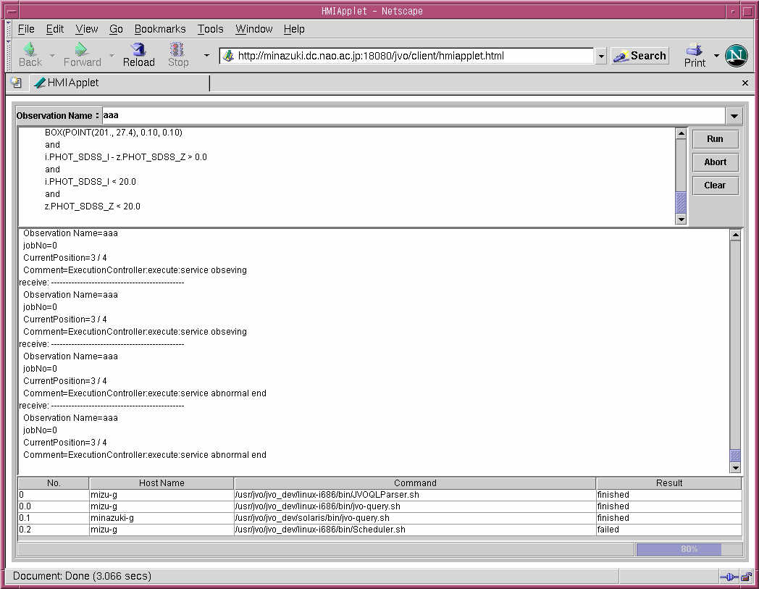
JVO QL
の指定
（分散データの
SQL
拡張）
仮想観測名
を指定
実行・停止・
clear
の指示
サービス実行制御の
ログ表示
サービスの実行履歴・予定 （動的に変化）
［実行先ホスト名、コマンド名、結果］
JVO
プロトタイプ画面
Specify JVO QL
Run/Abort/Clear Button
Logging Info of the Execution
Display Workflows, Host Names & Commands, and Status of each step
JVO Prototype
Figure 3. The User Interface of the JVO Prototype.

2 Future Issues

2.1 Large Overhead of the Globus Tool Kit
Overheads when each command are executed are TOO LARGE. They are typically 7-8 seconds ! Since the queries are mainly executed as the batch jobs, such a large overheads could be accepted. However if we consider that data analyses will be performed as the foreground jobs, which will be implemented in the next version of our prototype, such a large overheads are not accepted. One method to solve this severe problem is to utilize the OGSA. Anyhow we need to minimize the large overheads.

Implementation of Data Analyses Components
We need to implement data analyses components to make our prototype the Virtual Observatory. In the past we have developed a distributed data analysis system for the Subaru telescope (the DASH – Distributed Astronomical Software Hierarchy), data analysis system for the radio telescopes at the Nobeyama Radio Observatory (a branch of the National Astronomical Observatory of Japan), the NEWSTAR, and its Java-version. Because we already have so many components to be used on the VO environment, we plan to implement these components into the next version of the JVO prototype in the year 2003.
  - Connection over the Firewall
It is necessary to provide the VO functions over the firewall. Since astronomical data on public databases could be located in the DMZ, we may consider to locate the JVO system in the DMZ, too. Of course we need to consider how to avoid destructive accesses.

__________________________________

