A Prototype toward Japanese Virtual Observatory (JVO)

Masatoshi OHISHI¹, Yoshihiko MIZUMOTO¹, Naoki YASUDA^{1,2}, Yuji SHIRASAKI¹,
Masahiro TANAKA¹, Satoshi HONDA¹, and Yoshifumi MASUNAGA^{1,3}
1: National Astronomical Observatory of Japan,
2-21-1, Osawa, Mitaka, Tokyo 181-8588, Japan
2: Institute for Cosmic Ray Research, University of Tokyo,
5-1-5 Kashiwa-no-Ha, Kashiwa, Chiba 277-8582, Japan
3: Ochanomizu University, 2-1-1, Otsuka, Bunkyo, Tokyo 112-8610, Japan
{masatoshi.ohishi, mizumoto.y, naoki.yasuda, yuji.shirasaki, masahiro.tanaka, honda.satoshi}@nao.ac.jp, masunaga@is.ocha.ac.jp

Abstract

The Japanese Virtual Observatory (JVO) aims to provide astronomers to access federated astronomical databases (especially SUBARU, Nobeyama and ALMA) and data analysis environment by using the Grid technology. We defined a unified query language to access federated astronomical databases, the JVOQL, and constructed a prototype of the JVO. We adopted Globus Tool Kit 2 (GTK2) in this prototype to see its effectiveness in VO type application, especially for remote operations and file transfers, and UDDI for looking up services.
We found that the system worked as we had expected, however, it took very long to initiate each Grid process. Thus we replaced the GTK2 with a tool distributed by NSF Middleware Initiative, and shortened the polling interval of the job-manager from 30 seconds to 3 seconds. As a result, the serious problem has been partially resolved – the elapsed time for a query became about a half compared with the previous one.

1. Introduction

The National Astronomical Observatory of Japan operates the Subaru telescope (optical and infrared) in Hawaii and large radio telescopes in Nobeyama which is located about 150 km west of Tokyo. All the observed data are digitally archived and are accessible via internet. The radio telescopes of Nobeyama produce about 1 TBytes per year, and the Subaru telescope outputs about 20 TBytes per year. Because astronomical objects radiate electromagnetic waves in wide frequency range, it has been recognized that multi-wavelength analyses are essential to understand physical and chemical behavior of galaxies, stars, planets and so on. However, there was a severe restriction to access such amount of data; the network bandwidth between the NAOJ and the Internet was only 10 Mbps. Therefore it was very difficult for astronomers to download large amount of observed data, and it was also hard for them to analyze the multi-wavelength data through accessing to high performance computing facilities provided by the NAOJ.
In 2002 the National Institute of Informatics of Japan started to operate a new network, the SuperSINET (http://www.sinet.ad.jp/english/), and the NAOJ has become an important node for the SuperSINET. The SuperSINET is an ultrahigh-speed network intended to promote Japanese academic research activities by strengthening collaborations among leading academic research institutes. The backbone network connects leading research institutes in Japan with a bandwidth of 10 Gbps. The bandwidth between the NAOJ and the SuperSINET is 10 Gbps, and leading astronomical research institutes are directly connected with the NAOJ through VPN with the bandwidth of 1 Gbps.

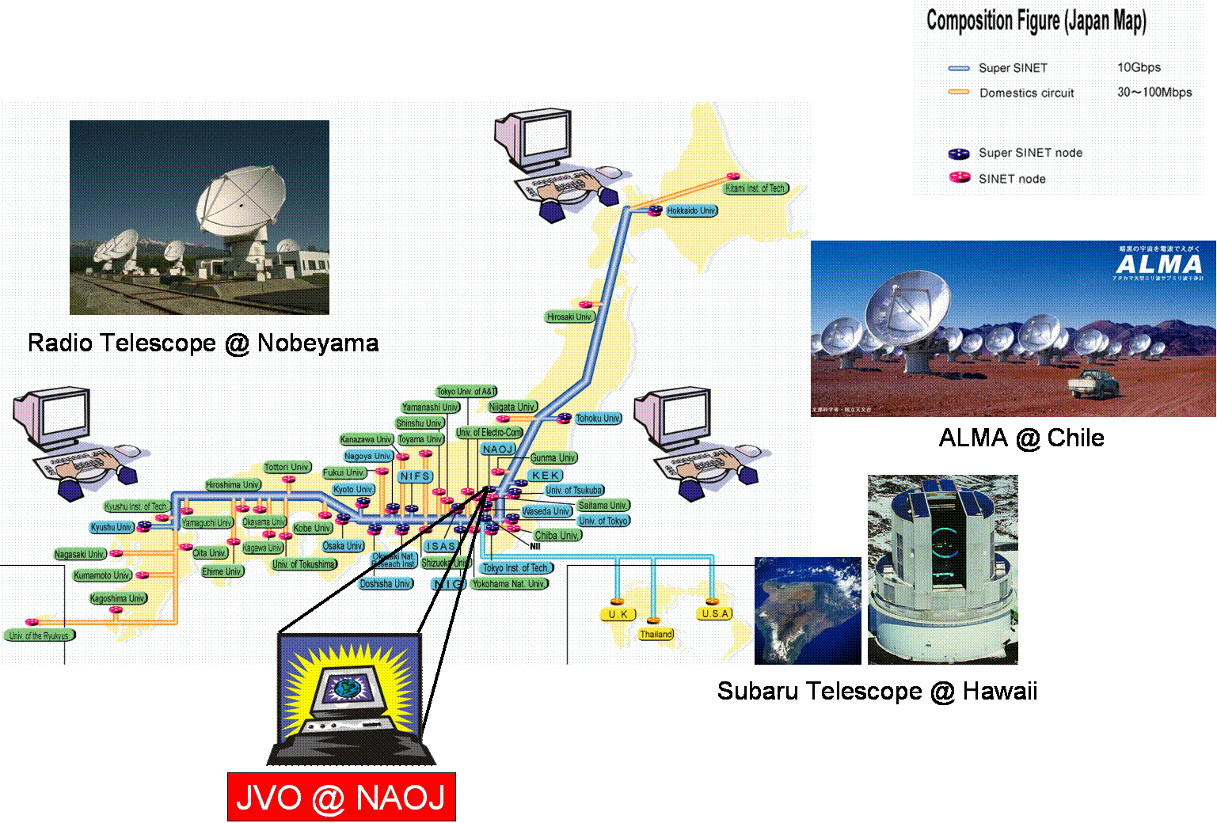
Figure 1. Japanese high speed network, SuperSINET, and large astronomical facilities operated (and will be operated) by the NAOJ

Such a new computational revolution has enabled us to create a new research environment which astronomers have longed for many years. The JVO is designed to seamlessly link distributed databases (DB) and data analyses systems for the Subaru, Nobeyama and other observational facilities in many research institutes by utilizing the state-of-the-art GRID technology through the 10 Gbps SuperSINET.
This paper describes basic structure of the Japanese Virtual Observatory system and details of our first prototype toward JVO.

2. Overview of the JVO system

Figure 2 shows a conceptual overview of the JVO system. JVO consists of a distributed computing system (DCS) which is deployed over high-speed networks such as the SuperSINET by utilizing the GRID technology.
The registry plays quite an important role in the JVO system, which provides information required for DCS to resolve servers which provide requested services, locations of distributed DB servers, data analysis servers, and so on. All computers of the DCS may have independent functions. However many of them need to have redundant functions with others to guarantee robustness of the JVO system. The JVO portal receives user requests, describe them in JVOQL (see section 3), and pass them to JVO controller. JVO controller manages all jobs; it automatically selects the most appropriate machine for a given task requested by JVO users, and returns the results from remote servers to the users.

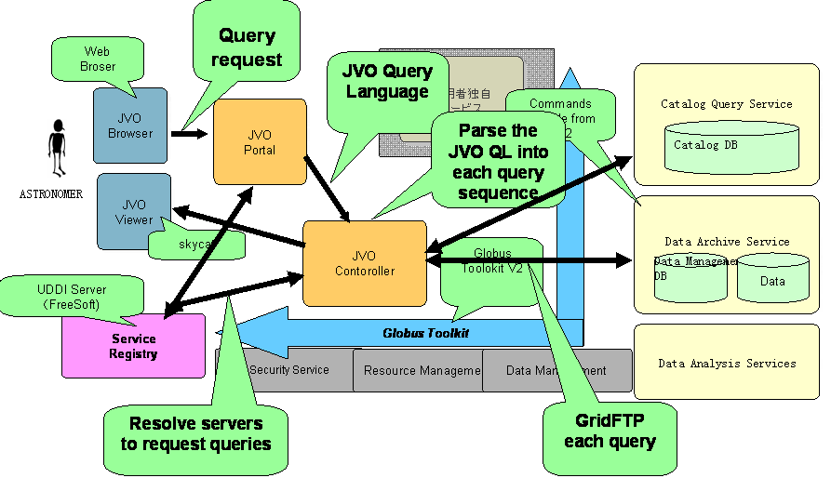
Figure 2. The schematic diagram showing interrelations among components of the JVO system

3. JVO Query Language

So far standard relational database language, the SQL, is widely used, and most of astronomical databases are implemented as the relational databases. However, because the SQL is designed to have generic query functions, it does not contain specific query functions to astronomical use. In astronomy a spherical coordinates are used to describe positions of celestial objects. The coordinates are similar to the latitude-longitude system to express any position on the surface of the Earth. The celestial longitude – the right ascension – ranges between 0 hour 0 minute 0 second and 23 hours 59 minutes 59 seconds, and 1 second next to 23 hours 59 minutes 59 seconds is 0 hour 0 minute 0 second. (Note that 1 hour corresponds to 15 degrees of arc.) Therefore a query language for astronomical use needs to handle such coordinate system.
We defined a new query language, JVO Query Language (JVOQL). It is designed to keep upward-compatibility with the SQL to enable in handling image data and cross-matching among distributed databases. Samples of JVOQL are illustrated in Figures 3 and 4.

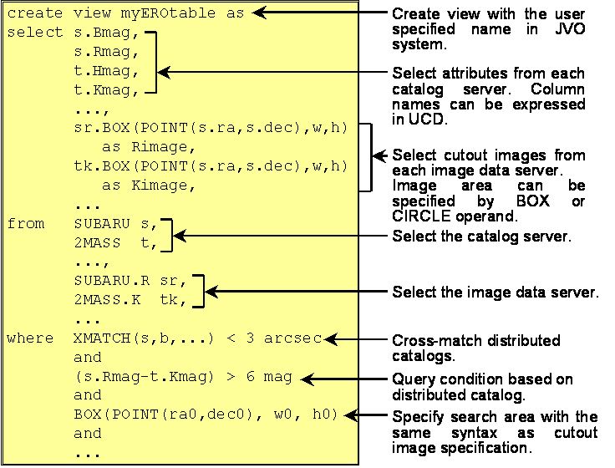
Figure 3. A sample of the JVO Query Language showing queries for catalog searches

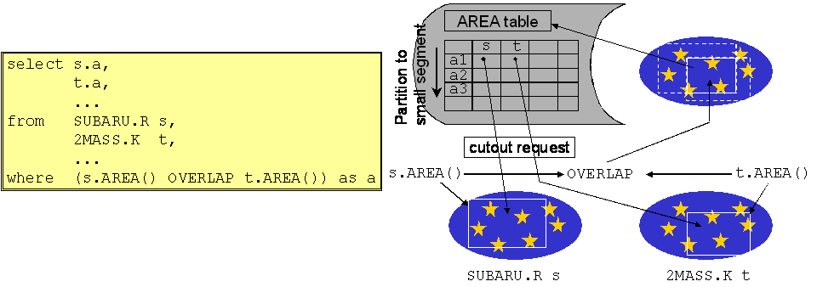
Figure 4. A sample of the JVO Query Language showing queries to search for images

JVOQL has an ability to query image data without referring to catalogs. This function is useful for multi-color (wavelength) or multi-epoch analyses. An example of JVOQL (Figure 3) shows how to obtain R-band images taken by SUBARU and K-band images by 2MASS in an area where both SUBARU and 2MASS observed. (Both R- and K-bands are in infrared region.) The operand “OVERLAP” returns overlapped area of the two data. Figure 4 shows an example to search for requested images. Similar to Figure 3, the operand “X.AREA()” returns the observed area of server X.
The interpreter of JVOQL communicates with the registry to find available databases, and issues query sequences to the distributed databases.

4. Implementation of the JVO prototype

We implemented our first prototype in a closed subnet in NAOJ. The architecture of the JVO prototype is shown in Figure 5. We adopted to use the Globus Toolkit 2 for the prototype. However we also take into account the Web service concept which is included in the OGSA.

4.1. Architecture of the prototype

The prototype consists of four servers, all with the Giga bit Ethernet interface. One server is the Sun Blade-1000 with Solaris8, and the rest are PCs with the RedHat Linux. We installed Oracle9i in one server, and PostgreSQL in other three servers. Oracle9i is the only commercial software in our prototype. Other software components such as JVO controller, JVO client, JVOQL parser, cross-match engine, image cut-out engine, etc., were implemented by using Java, C, servlet, ruby, Tomcat, and so on.

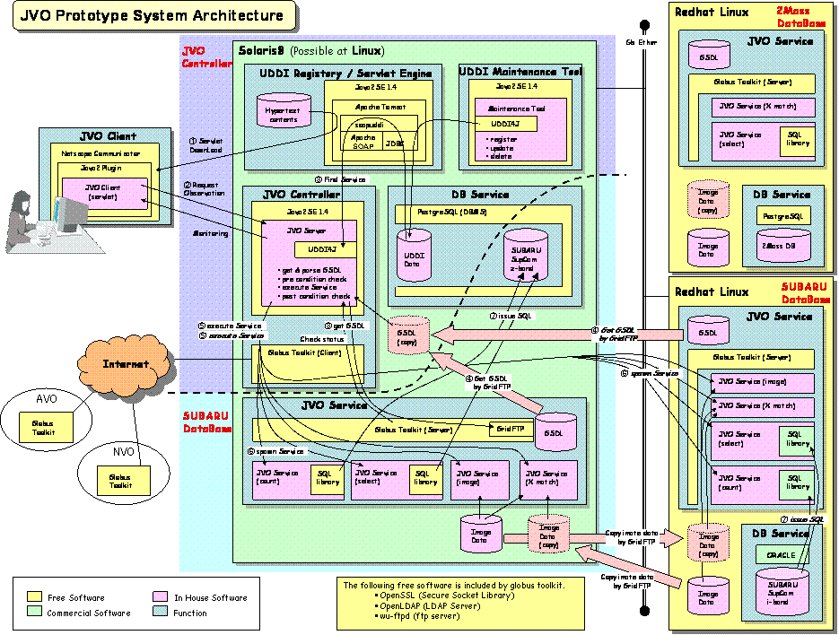
Figure 5. Architecture of JVO prototype. Note that the prototype has not been connected to other VOs yet.

4.2. “Work flow” of the prototype

Here we describe how the prototype works. First of all, researchers provide the JVO with simple instructions, described by using JVOQL, how they want to perform their “Virtual Observation” through the JVO portal. The JVO portal interprets them and generates a “work-flow” through consulting the UDDI servers to find where available JVO services are registered.
Based on the work-flow, built-in or user-defined services are called sequentially by the JVO controller. Prior to command execution the JVO controller issues “pre-condition check” to make dynamic assignment of distributed resources according to their availabilities. When one step of the work flow is finished, the result is examined by “post-condition check” if the step finished successfully or unsuccessfully. If the step finished successfully, the JVO controller generates next step(s) of the work flow and executes them. If the step finished unsuccessfully, the JVO controller searches for another server which provides the same service, and executes the same step on that server, if available. Successful execution results of the work flow are transferred from remote servers to the JVO controller through GridFTP, and are presented to the researchers with the JVO client.
We adopted VOTable [1] as an output format. In VOTable, physical quantities are structured with sophisticated semantic information, so that applications and data can be connected automatically and intelligently. VOTable is designed for Grid computing: it can represent very large datasets by using XML to describe the data stream, but parallel binary streams for the data itself.
In the past, astronomical data services returned human-readable content that a machine could not understand, so it was difficult to link distributed services into networks and Grids. However, VOTable is in XML format, meaning that computers can easily read, filter, and output to other computers, allowing federation and joining of information resources.

4.3. Cross-match procedure

It is a very important service in the JVO to cross-match (X-match) query results from multiple wavelength data. Each query is sent from the JVO controller to appropriate database server. Then the smallest query result is GridFTPed from the server to another server with the next smallest result. The recipient server is asked to run its X-match engine, and the result is further GridFTPed to a server with the third smallest query result. Final result is GridFTPed to the JVO controller.

5. Assessment of the prototype

We used several JVOQLs to assess this prototype. Table 1 contains each step of the work flow and elapsed time for each step, which corresponds to the case of sample JVOQL in figure 3. Two servers are seen in this table: mizu-g is a Linux machine and minazuki-g is a Solaris machine. Mizu-g is installed with the JVO controller. We used a WindowsXP or a Linux PC as a JVO client. The client PC was connected with a 100Base-TX intranet of the NAOJ, which was a different subnet from that for the JVO prototype.

Table 1. A sample of work flow and elapsed time
Step # | Host | Command | Elapsed Time
0 | mizu-g | JVOQLparser.sh | 1’ 12”
0.0 | mizu-g | jvo-query.sh | 1’ 15”
0.1 | minazuki-g | jvo-query.sh | 1’ 09”
0.2 | mizu-g | Scheduler.sh | 1’ 14”
0.2.0 | mizu-g | jvo-query.sh | 1’ 15”
0.2.1 | minazuki-g | post-xmatch.sh | 1’ 33”
0.2.2 | mizu-g | jvo-query.sh | 1’ 21”
0.2.3 | minazuki-g | jvo-query.sh | 2’ 26”

Table 1 contains several commands described as shell scripts: JVOQLparser.sh reads input JVOQL script and parses into individual queries in SQL; jvo-query.sh issues individual queries to database servers, counts up database records hit, and cut images out from image databases; Scheduler.sh collects count results and determines the order to request database servers query results and image data; and post-xmatch.sh kicks off cross-match engine. These commands were submitted by using the GRAM service of the Globus Tool Kit 2. As we expected, all steps were generated automatically, and we could get results successfully.
We examined robustness of our prototype by forcing the system to issue a command, at step 0.2.2, which would fail at one server but succeed at another server. At first the issued command to the “wrong” server failed, but then the system reissued the same command to the “right” server thought dynamic generation of the work flow.
However we found the elapsed times were too long for all steps. We knew that an elapsed time for each command was less than a few seconds when it was issued in non-globus environment. It should be noted that the final step, 0.2.3, corresponds to cut out images and needs very long CPU time even in non-globus environment. Such very long elapsed times seemed to be due to the authentication process and the “globus-job-run” command of the Globus Tool Kit 2. It is well known that the authentication process takes nearly 10 seconds and the “globus-job-run” command takes long during its initial hand-shaking procedure before issuing a “real command”. Since JVO is a pseudo-real-time system, it was crucial to shorten such large overhead in each process.

6. Improvement of the prototype

We introduced the NSF Middleware Initiative (NMI) [2] to accelerate slow authentication process in the Globus Tool Kit 2, because NMI provides a binary module for the authentication. Then we analyzed the source code of the “globus-job-run”, and found that polling interval was fixed to 30 seconds. Therefore we modified the polling interval to 3 seconds, and recompiled the tool kit. As the result elapsed times in Table 1 were shortened more than a factor of 2. For example the elapsed time for step 0 became 20 - 25 seconds.
Although we succeeded to accelerate all steps in our prototype, the elapsed times are much longer compared with those for cases in non-globus environment. Thus it is necessary to investigate further, for example, the source code of the tool kit to make our system to run much faster.

7. Application in searching for gravitational lenses

We applied the prototype for astronomical application. We searched for candidates of gravitational lens objects produced by cosmic strings [3] in image data taken by the SUBARU telescope. Because cosmic strings are thought to have its width of about 10⁻²² m but its weight of 10 km string would be similar to that of the Earth, a region around the strings would be distorted due to the general relativistic effect. Therefore a galaxy behind the cosmic string would be observed as a “double galaxy” with very similar brightness and shape independent of wavelength. And such “double images” would be seen aligned along the cosmic strings.
We used the SXDF data (three bands) taken by the Subaru telescope, and installed each band data as a single database in the JVO prototype. We also installed some engines for data analyses: color-color diagram generator spectral energy distribution generator, and an engine to generate overlaid image from three band images. A sample output is shown in figure 6.

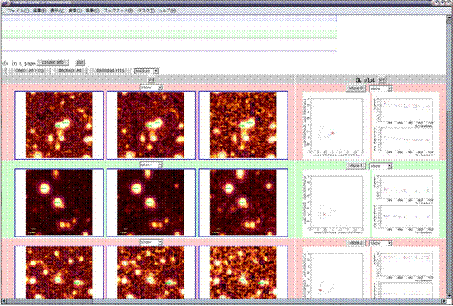
Figure 6. Sample output for gravitational lens searches. Each row contains three images from three bands, its color-color diagram and spectral energy distribution diagram (from left to right).

The search for gravitational lens candidates was found quite fast; it took only 2 – 3 minutes to produce such an output. If we searched for such “double images” by traditional method – by hand ! –, it would take at least a few hours. Therefore we could demonstrate that astronomers can use her/his research time quite effectively by using the virtual observatories.

8. Collaboration with other VO projects

There are other VO projects in the world: e.g., the National Virtual Observatory (NVO) in the US, the Astrophysical Virtual Observatory (AVO) in the EU, and the AstroGrid in the UK. These projects provide other databases in other wavelengths than those provided by the JVO. Therefore it is inevitable that the JVO needs interoperability with other VOs to enable researchers to access other databases in other wavelengths.
Thus we proposed to the International Virtual Observatory Alliance (IVOA – http://www.ivoa.net/) our specification of the JVOQL as a standard query language among virtual observatories in the world, and the JVOQL was adopted as a basis for such standard language in the IVOA [4].

9. Summary and Future plan

We constructed the first version of the JVO prototype, and defined a unified query language to access astronomical databases, the JVOQL. We confirmed that the JVOQL has sufficient functionality to access to federated databases. We adopted Globus Tool Kit 2 (GTK2) as an underlying middleware in this prototype to see its effectiveness in VO application, especially for remote operations and file transfers, and UDDI for looking up services.
We found that the system worked as we had expected, however, it took very long to initiate each Grid process. Thus we replaced the GTK2 with a tool distributed by NSF Middleware Initiative, and shortened the polling interval of the job-manager from 30 seconds to 3 seconds. As a result, the serious problem was partially resolved – the elapsed time for a query became less than a half compared with the previous one.
We plan to develop the second prototype based on our experience above. We plan to implement single-sign-on function to the JVO system, secure file access over the firewall, simple registration function of new databases, various data analysis engines, and so on, by the end of March 2004.

The authors appreciate Ken MIURA, Hirokuni MONZEN, Kenji KAWARAI, Yasuhide ISHIHARA, Yasushi YAMAGUCHI and Youji YANAKA of Fujitsu Ltd. during the development of our prototype. This research was supported by Grant-in-aid “Information Science” carried out by the MEXT (14019092 and 15017289).

10. References

[1] http://cdsweb.u-strasbg.fr/doc/VOTable

[2] http://www.nsf-middleware.org/

[3] Y. Shirasaki, Y. Mizumoto, E. Matsuzaki, M. Ohishi, N. Yasuda, M. Tanaka, S. Honda, H. Yahagi, M. Nagashima, G. Kosugi, N. Kashikawa, F. Kakimoto, and S. Ogio, “Searching for a Cosmic String through the Gravitational Lens Effect: Japanese Virtual Observatory Science Use Case”, Astronomical Data Analysis Software and System XIII, the Astronomical Society of the Pacific, Strasbourg, October 13-15, 2003, in press.

[4] N. Yasuda, W. O’Mullane, T. Budavari, V. Haridas, M. Hill, N. Li, T. Linde, T. Malik, B. Mann, Y. Mizumoto, M. Ohishi, C. Page, and A. Szaley, “Astronomical Data Query Language: Simple Query Protocol for the Virtual Observatory”, Astronomical Data Analysis Software and System XIII, the Astronomical Society of the Pacific, Strasbourg, October 13-15, 2003, in press.

